Course Work Answer Book
UNIVERSITY COURSE WORK

REGISTRATION NUMBER |  |  |  |  |  |  |  |  | VU-BCS-2603-3388-DAY
Title of The Program (eg BBA, BSC, BPH, BSWA) |  |  |  |  |  |  |  |  |  |  |  |  | BCS
Bachelor of Science in Computer Science
Department |  |  |  | Other Depts in Faculty of Science and Technology
Faculty | Faculty of Science and Technology
Year Of study (YrI , YrII, YrIII, or YrIV) |  |  |  |  |  |  |  |  |  |  | 1
Module Code and Name |  |  |  |  |  |  | 1203 ST
Programming Fundamentals
Semester |  |  | 2
Retake: |  | Yes |  |  | ☐ |  |  | No |  | ☒ |  | (Tick whichever is applicable)
Date of Course Work |  |  |  |  |  | Mon Aug 31 2026 00:00:00 GMT+0300 (East Africa Time)
DIRECTIONS TO CANDIDATES (Turn to page ii for more instructions). |  |  |  |  |  |  |  |  |  |  |  |  | FOR USE BY EXAMINERS ONLY
 |  |  |  |  |  |  |  |  |  |  |  |  | Question Number | Internal Examiner | External Examiner
- Leave margin blank.
- Begin each answer on a fresh page.
- Write the number of each question and theCandidate's Number at the top of each page.

- Write the numbers of the questionswhich you have attempted, with subsections where necessary, in the spacesprovided below

 |  |  |  |  |  |  |  |  |  |  |  |  | TOTAL

NUMBER OF QUESTIONS you have answered in the order in which you have written them

How and where should I submit my Course Work script?
Every student will be required to submit their Course Work via VClass Students Portal E.g. you go to www.vclass.ac and login, to your account, then on the left sidebar menu click on Course Work.
Under Course Work you will see the following: -
- Instructions for that particular Course Work with time required to finish your Course Work as per instructions,
- A student will be required to download the question paper and the answer sheet provided by the university within the same module Course Work, or a student can be required to attempt structured questions within the system depending on how the Course Work was set.
- Submission of answered questions is done,
- Student is required to click to consent to show that the answered Course Work belongs to them.
- Note that if Course Work is for download, a student will be required to download the question paper and answer sheet, do their Course Work within the given stipulated time.
- Required to scan and upload back the answered booklet through the same portal as per format available.
- Course Work uploaded will directly be received by the Registry department.
- Students here are required to use VClass e-Learning systemfor all Course Work and for any failure they can contact the Registry department for guidance.
- No late submission will be accepted.
Avoid any malpractice because this will attract severe penalties such as invalidating the answered script whose consequences will attract retakes.
THE SMART STUDY PLANNER
1. System Description and Overview
The Smart Study Planner is a console-based Python application designed to assist students in tracking, organizing, and analyzing their study sessions across different academic subjects over a semester. As a student in Computer Science, managing study time across subjects like Programming Fundamentals, Data Communication, Discrete Mathematics, and Web Systems is essential for academic success.
The program provides a menu-driven interface that allows the user to log study sessions (specifying subject, topic, date or day label, and duration in minutes), automatically classifies session intensity into Short, Medium, or Long categories, displays all recorded sessions in an aligned table, searches sessions by subject name case-insensitively while computing total time spent, generates analytical statistics (overall hours, hours per subject, the least studied subject, and the longest single session), and preserves data across multiple runs by saving to and loading from a file named 'study_log.txt'.
2. Program Architecture and Function Breakdown
The program is organized into modular functions as shown below:
Function Name | Coursework Requirement | Summary of Operation
main() | Menu Interface | Runs the main loop, presents options 1 to 5, takes user input, calls the appropriate function, and rejects invalid inputs without crashing.
add_session(sessions) | Add Study Session | Prompts for Subject, Topic, Date/Day, and Duration. Validates that duration is a positive integer (> 0) with continuous re-prompting. Stores each session as a dictionary in a list.
classify_session(duration) | Duration Categorization | Returns 'Short' (<30 mins), 'Medium' (30-90 mins), or 'Long' (>90 mins) using conditional statements. Reused in all display functions.
view_sessions(sessions) | Tabular Display | Formats and displays all recorded sessions in a structured table with columns for No., Date/Day, Subject, Topic, Duration, and Classification.
search_by_subject(sessions) | Search by Subject | Performs case-insensitive subject search, displays matching sessions in a table, and calculates total time studied for that subject. Handles no-match cases cleanly.
study_statistics(sessions) | Study Statistics | Computes total overall hours, total hours per subject, the weakest area (least studied subject using min), and the longest single session (using max).
save_sessions() &  load_sessions() | File Persistence | save_sessions() writes records to study_log.txt on exit. load_sessions() loads existing records on startup and handles the missing file on first run without crashing.

3. Implementation Details and Logic
3.1 Session Classification Logic (classify_session)
The classify_session(duration) function takes the duration in minutes and uses conditional statements to return the appropriate category label:
• Duration < 30 minutes: Returns 'Short'
• 30 <= Duration <= 90 minutes: Returns 'Medium'
• Duration > 90 minutes: Returns 'Long'
This function is reused in add_session(), view_sessions(), search_by_subject(), and study_statistics() to maintain uniform categorization.
3.2 Defensive Input Validation (add_session)
To prevent runtime crashes and invalid records, add_session() validates all inputs:
1. Text inputs (Subject, Topic, Date/Day) are stripped of whitespace and checked in while loops to ensure they are not empty.
2. The duration input is validated inside a try-except block to ensure it is a valid integer, followed by an if condition to verify that duration > 0. If the user enters a negative number, zero, or non-numeric text, an error message is displayed and the prompt repeats until a valid number is provided.
3. Valid records are stored as dictionaries: {'subject': subject, 'topic': topic, 'date': date, 'duration': duration} and appended to the master sessions list.
3.3 Case-Insensitive Subject Search (search_by_subject)
The search_by_subject() function normalizes both the user search term and stored subject names using .strip().lower(). Matching records are displayed in a formatted table, and their durations are summed to calculate the total study time in minutes and hours. If no records match, the program displays a clear notice rather than an empty table.
3.4 Analytical Statistics Engine (study_statistics)
The statistics engine computes four key metrics:
• Overall study time: sum(s['duration'] for s in sessions) converted to hours (minutes / 60.0).
• Per-subject time breakdown: Durations are grouped by subject using a dictionary accumulator.
• Weakest area: Identifies the subject with the lowest total study time using min(subject_totals, key=subject_totals.get).
• Longest session: Identifies the single longest session recorded using max(sessions, key=lambda s: s['duration']).
3.5 Persistent File I/O (load_sessions and save_sessions)
Persistent storage is handled via 'study_log.txt' using pipe-delimited lines (subject|topic|date|duration). On startup, load_sessions() checks if the file exists using os.path.exists(). If the file does not exist (e.g. on first run), it returns an empty list without raising a FileNotFoundError. On exit, save_sessions() iterates through the session list and writes all records to the file.
4. GitHub Repository Access Link
https://github.com/M15-byte/SMART-STUDY-PLANNER.git
5. Step-by-Step System Testing and Output Logs
The following execution logs demonstrate the step-by-step testing of each menu option, including input validation and file persistence:
Step 1: Program Startup and Clean Session Loading
Demonstrates launching the application, loading existing records from study_log.txt, and displaying the main menu.
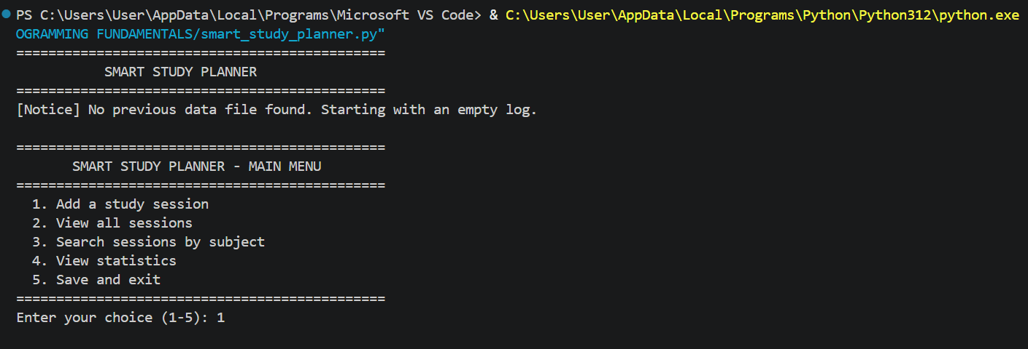
Step 2: Adding a Study Session with Input Validation
Demonstrates Option 1: Entering negative numbers (-45) and non-numeric input ('ABC') triggers error messages until a valid positive duration (45) is entered.

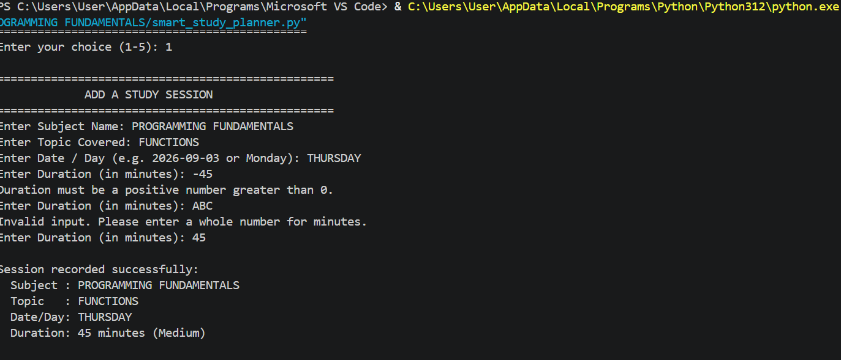

Step 3: Viewing All Recorded Study Sessions
Demonstrates Option 2: Displays all recorded sessions in a formatted table with calculated classifications (Short, Medium, Long).

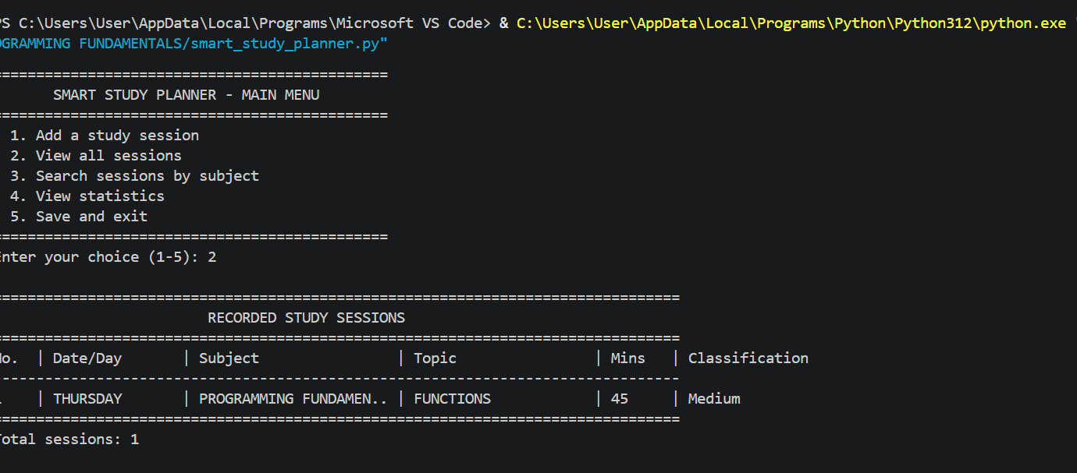

Step 4: Searching Sessions by Subject
Demonstrates Option 3: Case-insensitive search for 'programming fundamentals' displays matching records and total study time.

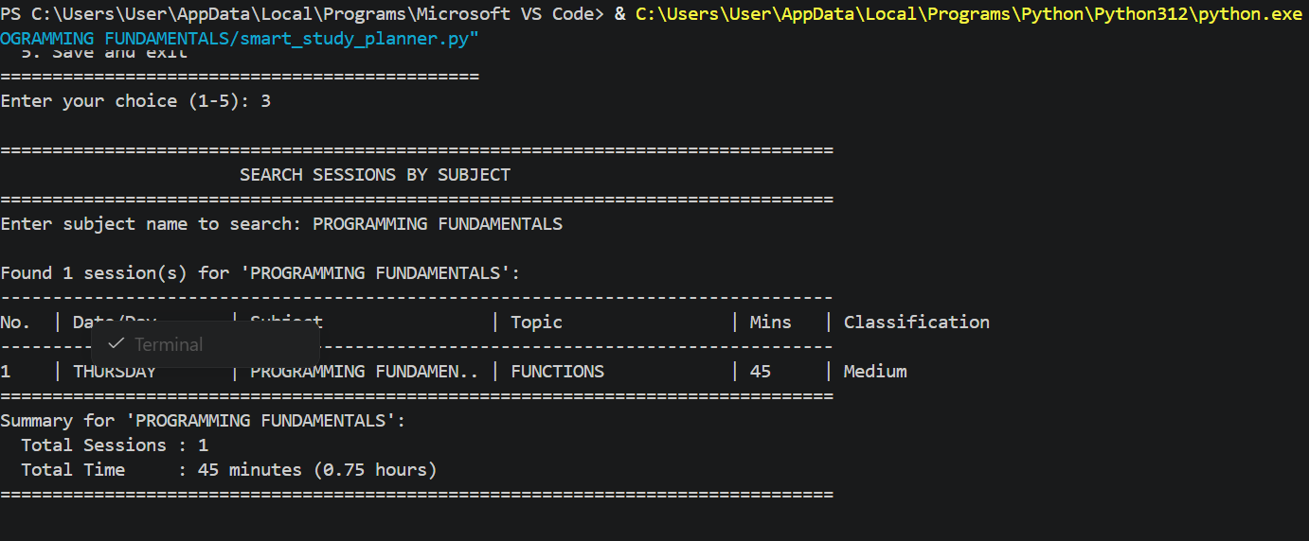

Step 5: Viewing Analytical Study Statistics
Demonstrates Option 4: Displays total overall study hours, per-subject breakdown, weakest area and longest single session

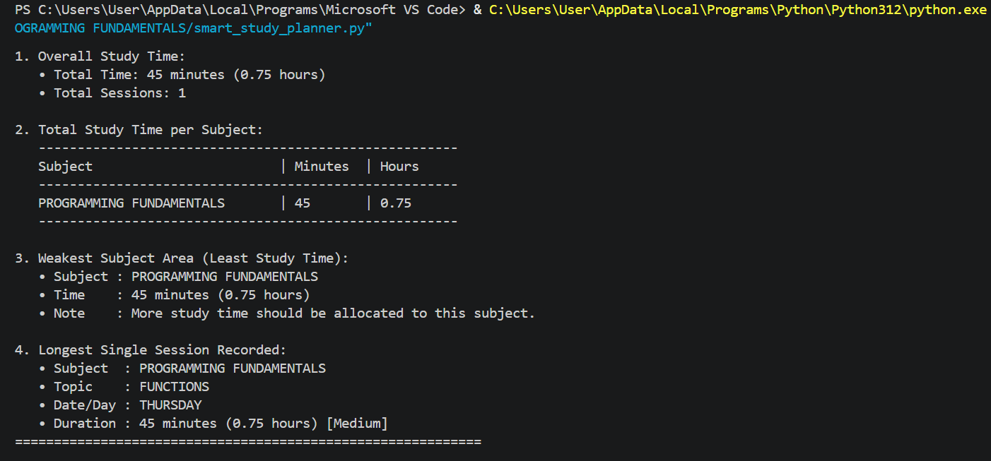

Step 6: Saving Data on Exit & File Persistence
Demonstrates Option 5: The program writes all session records to 'study_log.txt' and exits cleanly.
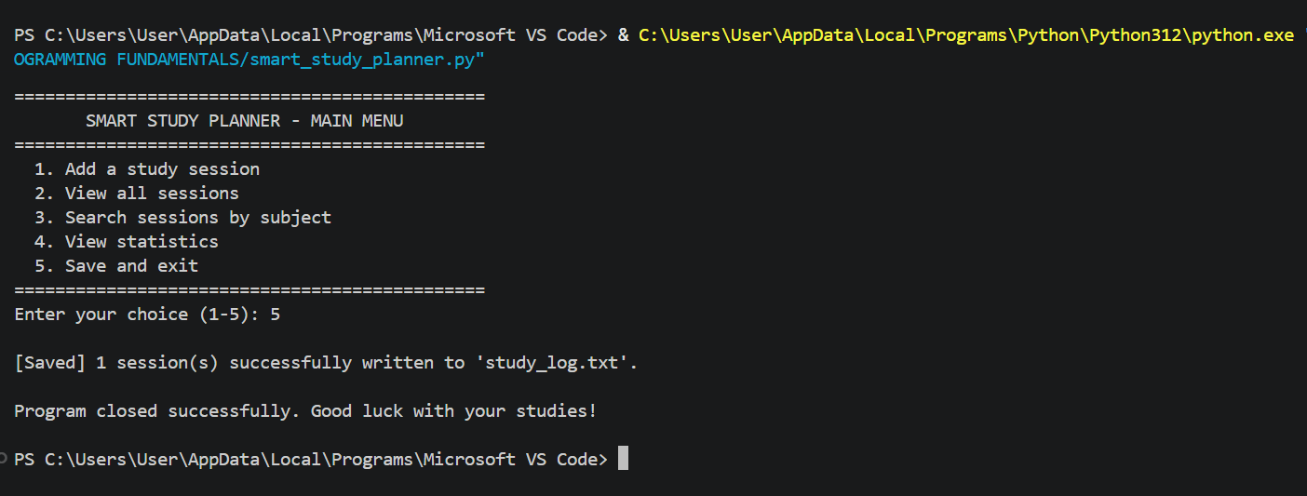

REFERENCE
GitHub Repository Access Link :
https://github.com/M15-byte/SMART-STUDY-PLANNER.git

